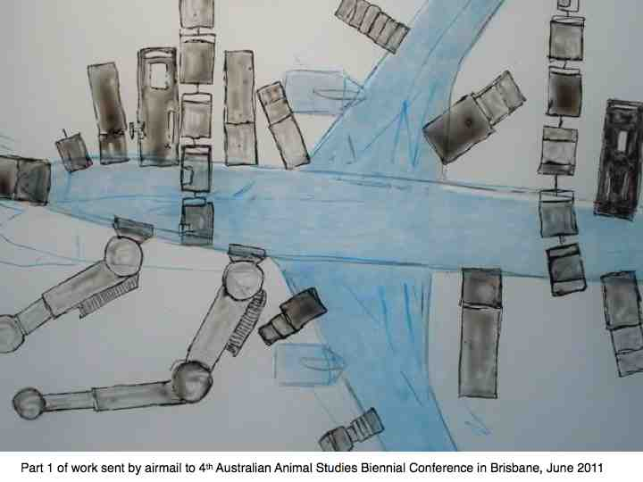Kate Foster, with Merle Patchett, Hayden Lorimer, Perdita Phillips
Collaborative creative work on environmental change – some examples from art and geography, with discussion.
Small print: All rights reserved, all images coprytight to Kate Foster unless otherwise stated. Permission in writing required from authors for reproduction of any image or use of recorded video material beyond personal use. Note all zoological specimens copyrighted also to Hunterian Museum and Art Galleries.
This follows talks on Clipperton Project, an expedition of artists and scientists going to an uninhabited island in the Gulf of Mexico. These presentations were in two halves – artists and scientists giving different takes. This is rather more intermingled, but still essentially two halves.
I will take about 15 minutes for reflections and a selection of work over the past ten years – showing a developing method in which collaboration is key. I have taken this talk as a prompt to sound out people I have worked with – an interdisciplinary artist Perdita Phillips and geographers Hayden Lorimer and Merle Patchett. In combination, we offer different experiences of how artists and academic researchers can forge alliances. We broach the question of the different criteria by which we can count success.
Slide 1: This links to the multiple on each seat, a set of airmail stickers. I hope if you read the small print, this stands on its own. This is a work finding its place, moving towards campaigning. It is about to be distributed at the 4th Australian Animal Studies Biennial Conference in Brisbane.
A working principle: anthropogenic (caused by humans) environmental change is a product of society - and we are all involved in shaping a cultural response.

Slide 2 (below) feeling overwhelmed – a state of anxiety rather than action (Amy Todman) - is all too familiar. But apart from artwork, there are many alliances and exchanges taking place. For example, ecoartscotalnd, and also Stop Climate Chaos is an umbrella for campaigning organizations who repeatedly point out the failure of governmental action on climate change. Alliances may provide company to soothe anxiety, but also help find ways to engage.
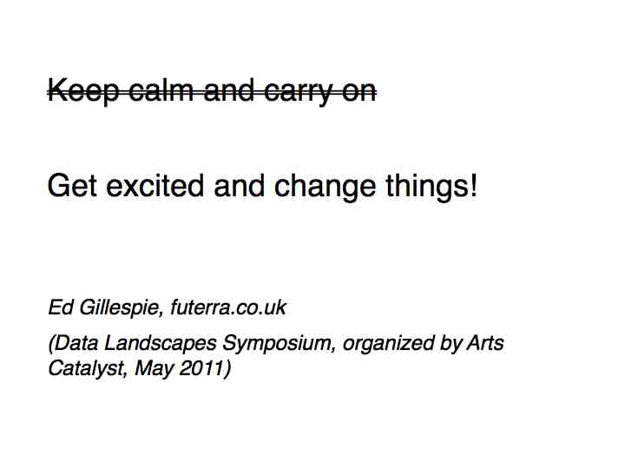

Slide 3: Working independently as an artist has been about finding platforms to work from, creating them for yourself if necessary. It means constantly reviewing if you are where you want to be, and how to get there if not. This piece originated when I realized I was on the road to getting institutionalized, but decided that I had to keep thinking what I like, and perhaps also what I don’t like too.
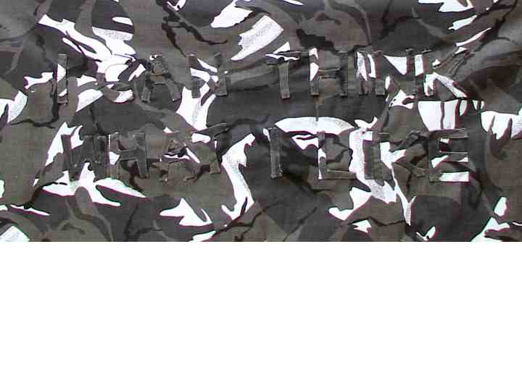
Slide 4: As a working method ‘changeable places’ (also a developing platform initiated with Jethro Brice) simply works with the idea that if you are immersed in a setting it helps to share your sense of that place, convey the layered connections to people with different outlooks and expertise – leading to discussion about what to communicate and how we engage with the setting’s future. A route for engaging with places with uncertain prospects in terms of land use, species loss, and climate change.
See http://www.changeableplaces.wordpress.com
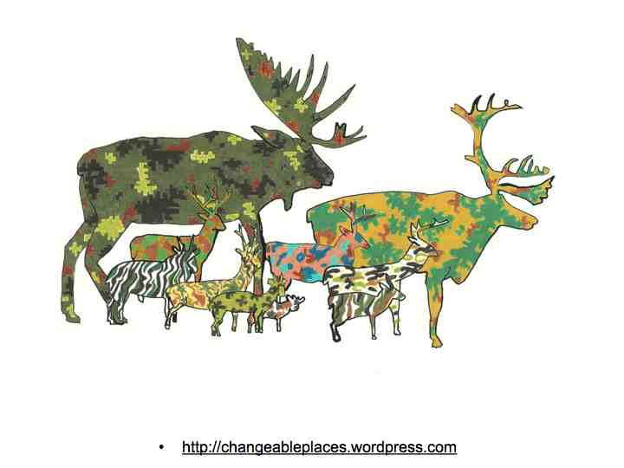
Slide 5: travel is also a recurring theme - a ‘journey menu’ - seeking home
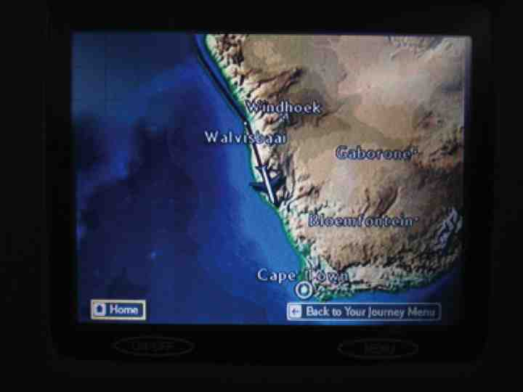

Slide 6: Projects I will mention, detailed on www.meansealevel.net
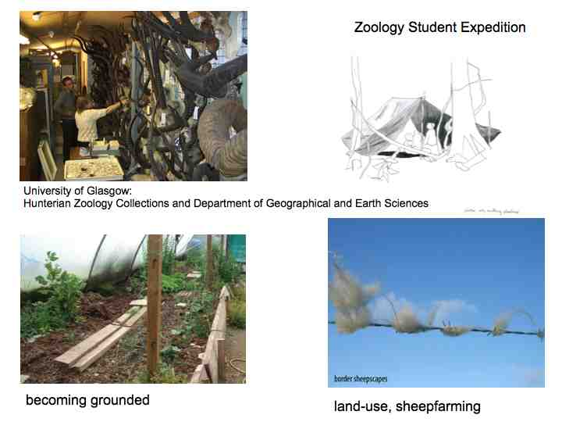
Slide 7: After leaving GSA 2001, working with GU zoology museum has played a key role in developing as an artist. It started as a strategy to understand more about extinction, death, animal existences. The effects of loss of biodiversity on ecosystems can be articulated through careful science. But what affect does it have? Developing an eye for interconnectedness has expanded and deepened what I care about.
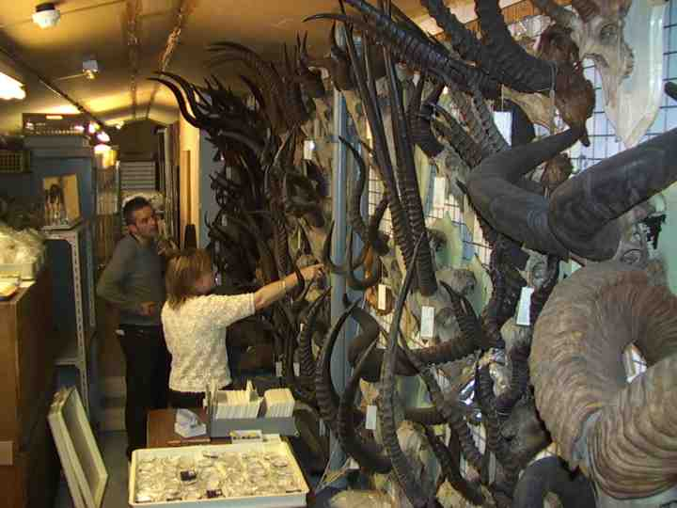
Acknowledgements to Hunterian Zoological Section, especially Maggie Reilly, seen here with Hayden Lorimer.

Slide 8: at this point able to reflect on different ways related to museum and its collections
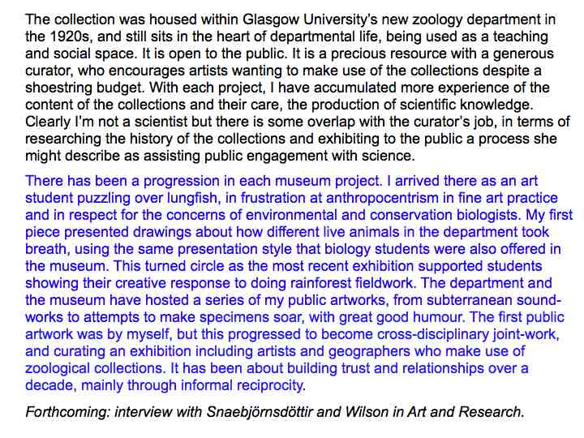
Slide 9: Contact with biologists led to a GU student expedition to Amazonian rainforest in Ecuador where my contribution was to help students communicate their work visually and creatively.
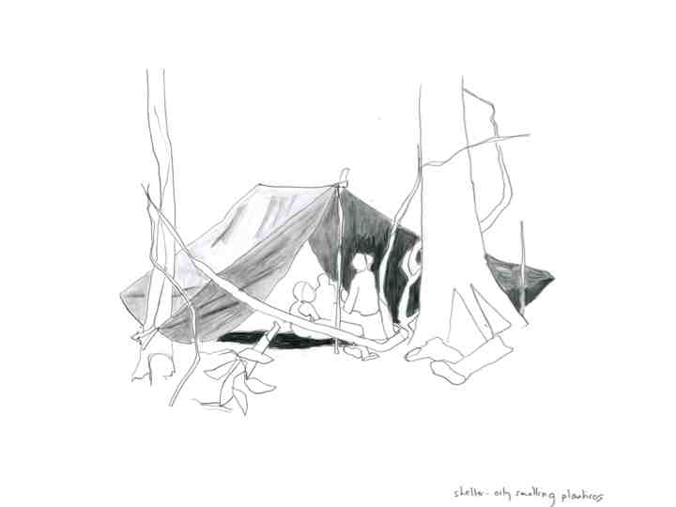
Slide 10: Their field task was to identify the incredible variety of frogs and birds they trapped. This register of biodiversity, it is hoped, supports the community of San Jose de Payamino in preserving their patch of Amazonian rainforest from minerals extraction or soy plantation.
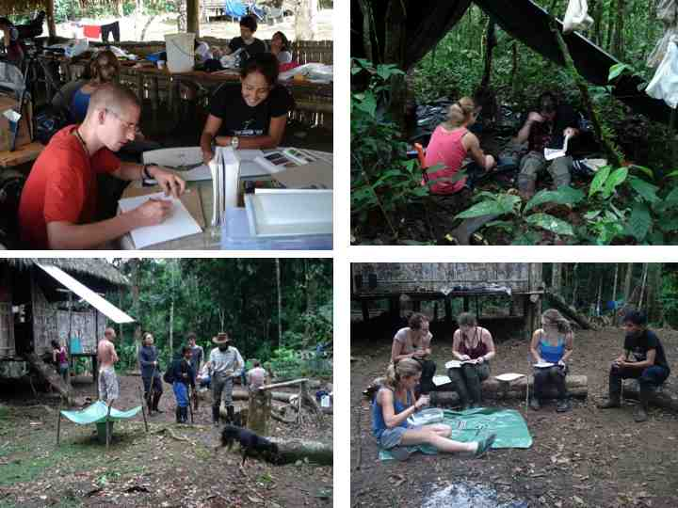
Slide 11 A two-part work by Glasgow University Ecuador Expedition, 2009 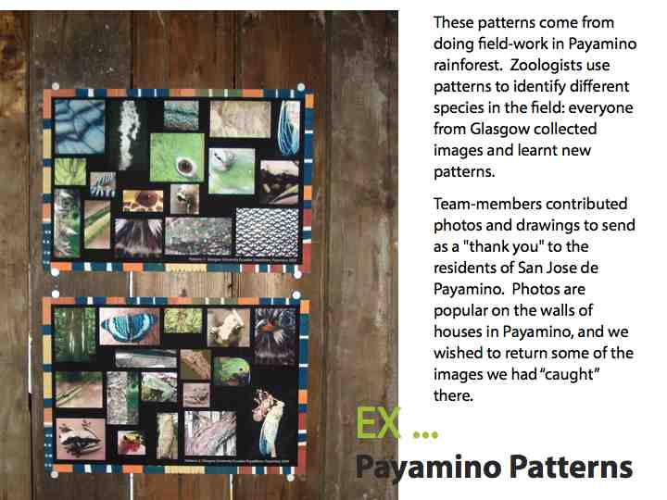
We sent one set for each household on waterproof laser paper Feedback is that the images were posted up in the house, on the doors in particularly, and the components recognized.
Slide 12: With Martin Muir – a PhD student in geography – we housed our respective creative responses to the expedition in the zoology museum – Martin built a rainforest hut, the show was called EX… Feedback from the students was that this helped process the experience of the expedition, and made them think about what to communicate, and how, to others who had not gone.
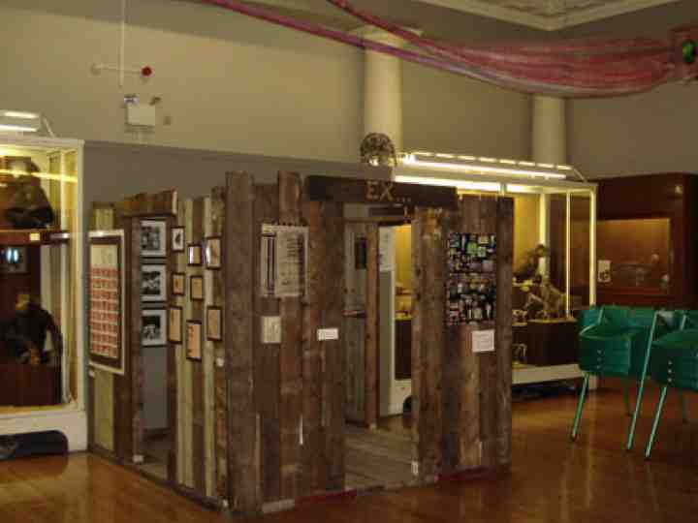

further details of weblink - contact martin muir martin.muir@ges.gla.ac.uk
Slide 13: my own contribution was sketchbook extracts, mainly about getting there and the work the students did. Two years later, I now have an idea of what my focus would be should I go again, but this has fed into a strategy to do more localized work instead, as you will see.
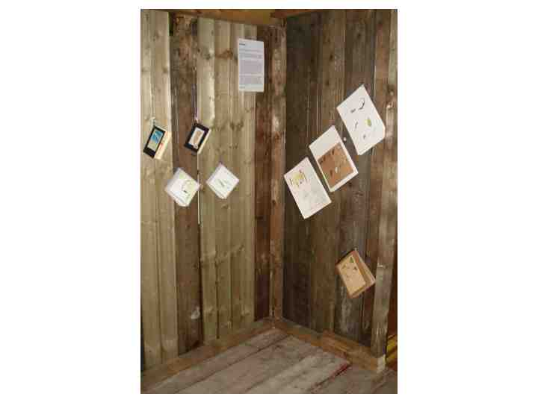
Slide 14. Now - about using the zoological collections in association with geographers
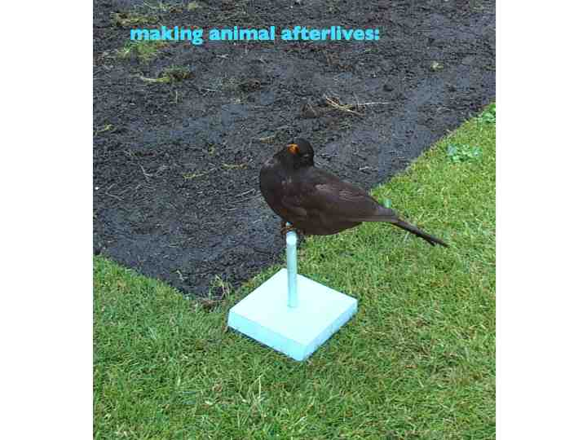
Slide 15: a series of Biogeographies stemming from zoological specimens of species in someway in the environmental limelight – perhaps an endangered endemic bird, a persecuted raptor, 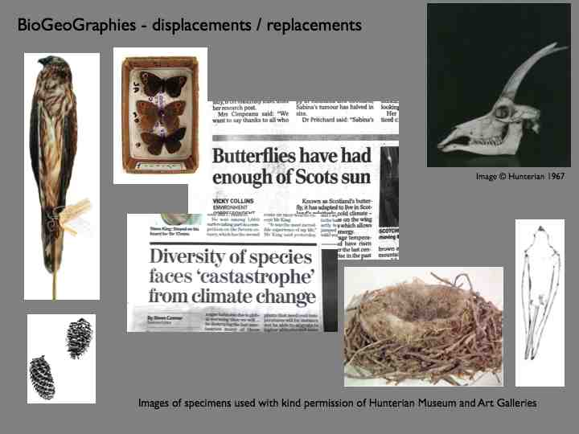
Slide 16: birds whose migration patterns are becoming more problematic, swallow skins here collected in Scotland and Africa.
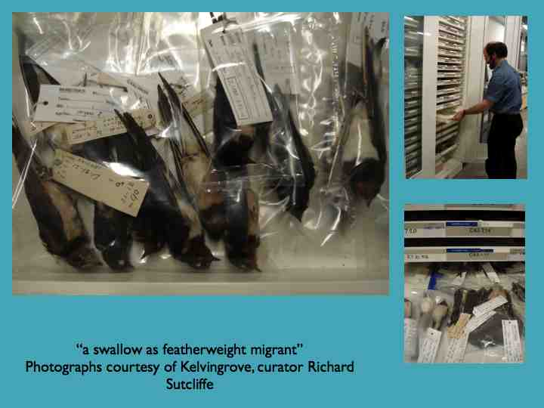
Slide 18: In 2003 I yielded to a desire to make a collection of body jewellery for birds affected by the Victorian plumage trade Initially exhibited in The Biography of a Lie, with Stephanie Connelly 2003, reworked as one exhibit in out of time, 2007. (including a travelling mantle for a swallow).
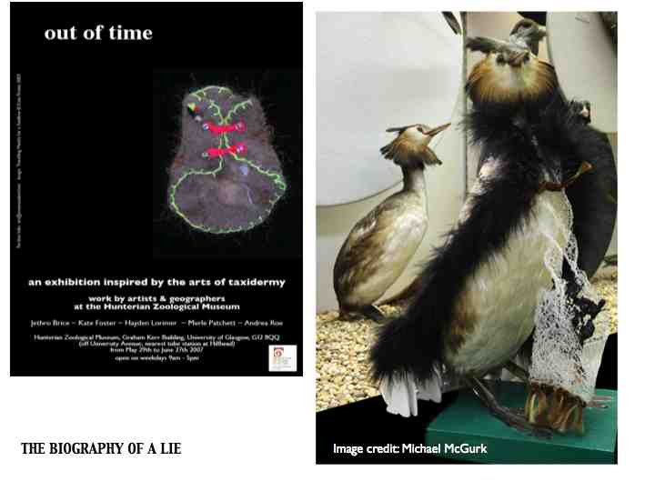
Slide 18: Each time this piece shown it its context accumulates. It is now part of a show curated by Merle Patchett last month – with artwork by Andrea Roe and an online catalogue about the plumage trade, clothing industry and birds of paradise.
See www.fashioningfeathers.com
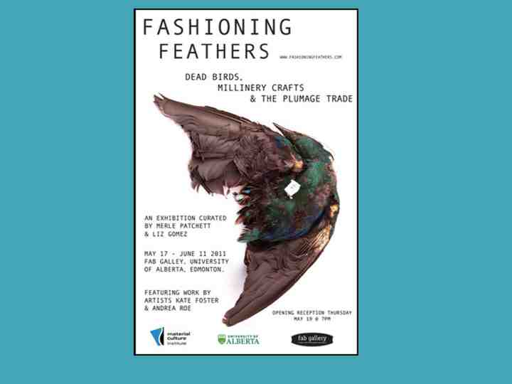
Slide 19: I enjoyed seeing this image of the head taxidermist at the Royal Alberta Museum fitting this item of Body Jewellery for endangered birds – redressing a historicalprocess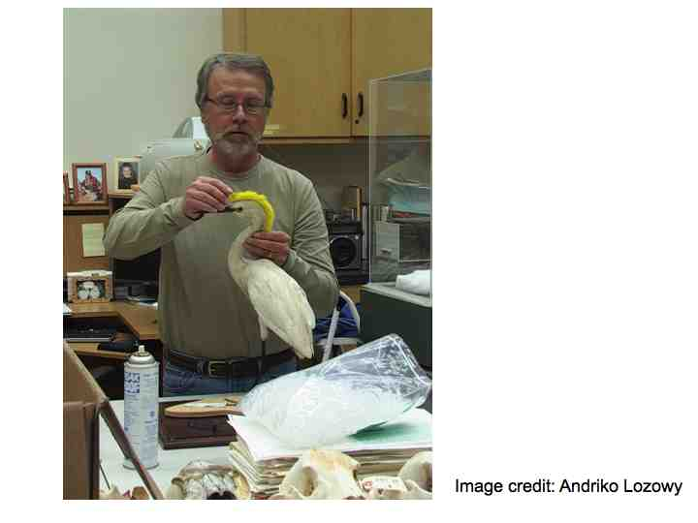
Slide 20: At this point want to mention a shared investigation in taxidermy, the subject of Merle’s PhD who developed links with museum staff, taxidermists, and artists.
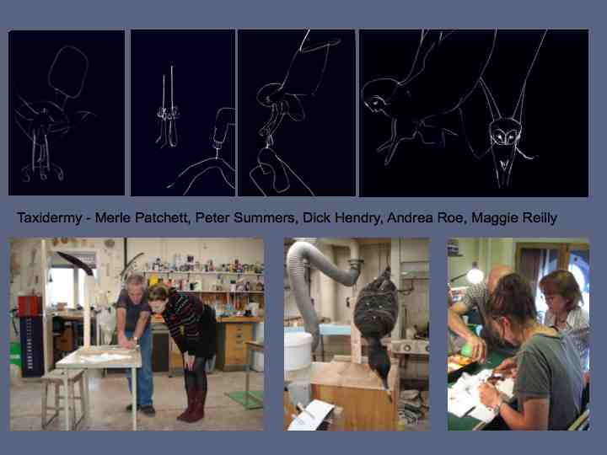
Slide 21: from my point of view most significantly focusing on the bluebuck, ongoing work that has provided small and tall stories, within a setting of grand and tragic narrative. 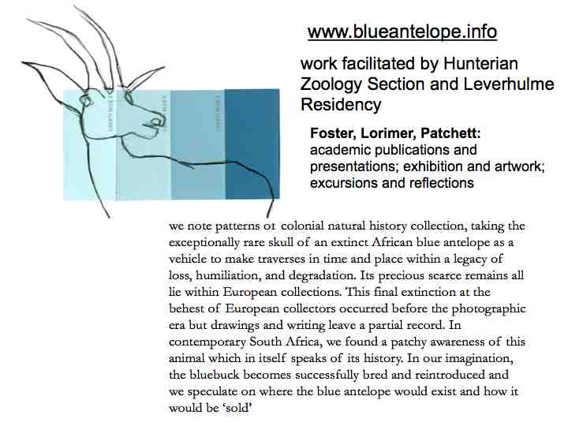
Please visit www.blueantelope,info for further info of slides 22-31.
31: Through a residency at visual arts department in Stellenbosch University, going to the site where the last documented bluebuck was killed, by a French explorer, le Vaillant – now Happy Valley
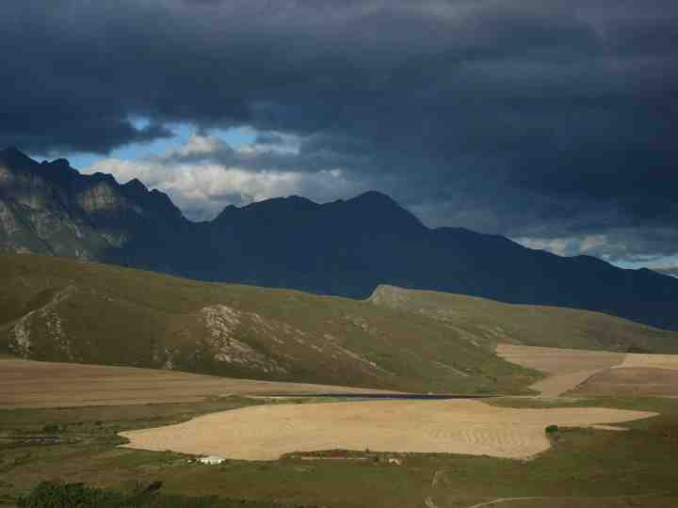
32: a scarcely remembered existence whose extinction heralded decimation of people, culture, and habitat.
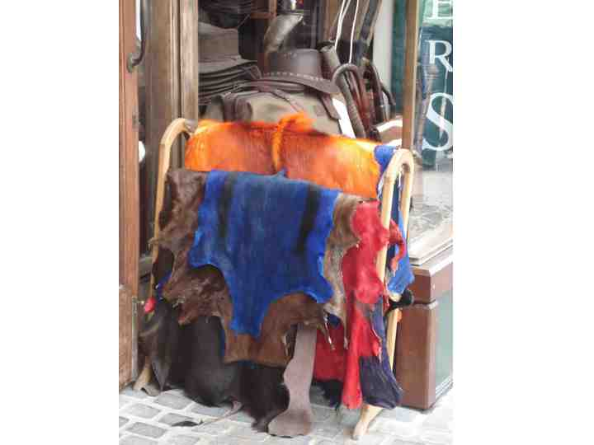
33: a change of scene – four years ago moved to the Borders.
How can I make my lfie more sustainable: 1. grow our own veg.
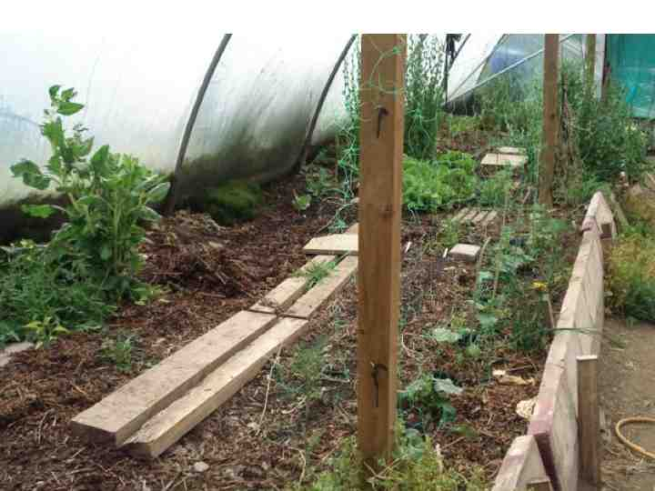
34: Through a visual arts award, task No 2 to understand more about land-use in my locality, to engage constructively.
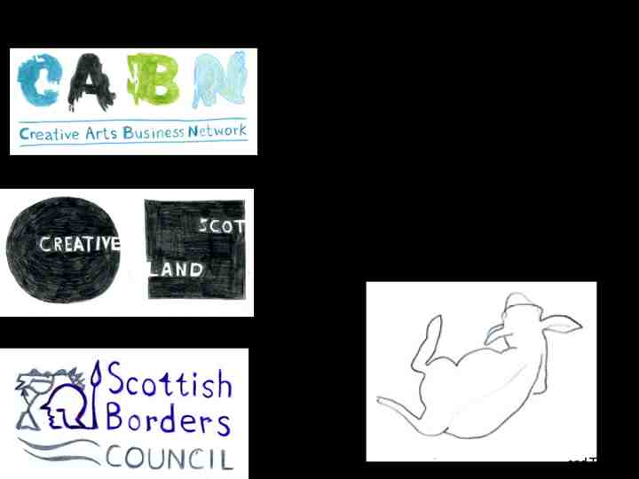
35 / 37 / 38/ 39 : Developing my own observation on sheepwalks and developing field drawing. As my farming neighbours realized, in much need of instruction – much time in the lambing shed. I am indebted to Macdonald Associates.
40: the next step, tree-lines, looking at clear-felling and more generatively, learning to cultivate and planting aspen from the tremendous pool of knowledgeable plantspeople in the Borders.
Please visit www.inthepresenttense.net for this work
Now for Part two of the talk
Recorded interviews with Merle Patchett and Hayden Lorimer available on this links:
http://merlepatchett.wordpress.com/2011/06/21/changeable-places-talk-at-glasgow-sculpture-studios/
They talk variously about experimental geography, making 'small stories', and creating networks for engaging with anthropogenic environmental change:
And contributions by Perdita Phillips:
To think more about what it means to work across disciplines, to introduce an an Australian interdisciplinary artist: Perdita Phillips. Please visit www.perditaphillips.com

KF: I realize that by seeking specialist knowledge I have to deal with feeling de-skilled. I realise I am developing nonexpertise, to develop collaborative relationships. What is Perdy’s experience?
PP:“Interdisciplinary for me has evolved to mean that the end result should be integrative which means I work with people where I feel I have "enough knowledge to get into trouble but not enough knowledge to get out of trouble". I need to be able to talk to people in way that is respectful of their discipline and have a reasonable window upon their world but I need to keep the position of a 'warm' listener. To be ethical; not to be an expert and also being able to step outside again - to get out of an in-discipline discussion. Otherwise it is somewhat conversely difficult to be integrative and to give back to both disciplines.
I tried to be truly interdisciplinary but found it wasn't a problem of my knowledge getting out of date (in science) but that I needed to not be estranged from the discipline because I wasn't fully participating. So therefore I do still feel I have a foot in both camps but one foot is bigger than the other.” Perdita Phillips
KF a discussion point: what do we count as success? Whose critique and criteria do we seek? Again a comment from Perdita Phillips, on the topic, what makes a collaborative project successful?
PP: “change, if ever so small; more questions generated at the end of the process; more ambitious projects (resources, reach, complexity, impact); projects that retain an unruly scent to them.

Failure is didactic, illustrative, closing down discussions.
Successful projects can be either or both:
weedy-- may be small but will always be a moving target -- unbalanced, unruly, difficult, complex.
non-weedy - able to build good connections, strong connections, more garden-like, the actors (human and nonhuman) are strongly connected but speak on their own terms, from their own umwelt, with their own points of view.”

